Abstract—
“Detection and Prediction of Brain Stroke Using Machine Learning with Radiomic and Clinical Feature Fusion”
Author:
Poorvika N.K.
Email: poorvi.nagavara@gmail.com
Affiliation:
Bangalore Institute of Technology,
V.V. Puram, Bangalore, India

Brain stroke is a critical medical condition that occurs when the blood supply to part of the brain is interrupted or reduced, leading to the sudden death of brain cells due to a lack of oxygen and nutrients. This interruption is typically caused by a blood clot obstructing a cerebral artery or the rupture of a blood vessel. Early and accurate prediction of brain stroke can be life-saving and significantly improve patient outcomes. This project integrates both structured data analysis and medical image-based prediction to enhance the reliability of brain stroke detection.
In the structured dataset, missing (NA) values were imputed using median values. A correlation matrix was analyzed, showing no significant multicollinearity among features. Categorical variables such as hypertension, heart disease, and stroke status were converted into string format and one-hot encoded using the get_dummies function. To address class imbalance, random oversampling was applied. All features were standardized using the Standard Scaler, and the dataset was split into training and testing sets in an 80:20 ratio. Multiple machine learning models were trained and evaluated, including K-Nearest Neighbors (KNN), Decision Tree Classifier (DTC), Random Forest Classifier (RFC), and XGBoost (XGB), achieving accuracies of: DTC – 97.32%, XGB – 98.04%, RFC – 99.33%, and KNN – 97.42%.
Additionally, this brain stroke project incorporates medical image classification using Convolutional Neural Networks (CNN), specifically the CNN-VGG model. The VGG model was chosen for its outstanding performance in image recognition tasks and its ability to extract deep, hierarchical features from CT scans. Leveraging pre-trained weights further accelerates model training while maintaining high accuracy. By combining both tabular data and image-based prediction, this project establishes a comprehensive and robust framework for early detection and classification of brain strokes.
Index Terms: Brain stroke prediction, CNN-VGG, Medical imaging, Machine learning, Data preprocessing, Classification, Confusion matrix, k-fold Cross-Validation.
I. INTRODUCTION
Stroke is a medical condition that occurs when the blood supply to the brain is disrupted—either due to a blocked artery (ischemic stroke) or a ruptured blood vessel (hemorrhagic stroke). This interruption deprives brain tissue of essential oxygen and nutrients, leading to the rapid death of brain cells. According to the World Health Organization (WHO), stroke is currently the second leading cause of death globally.
Among all stroke types, ischemic stroke accounts for approximately 87% of cases, followed by 10% caused by intracerebral hemorrhage and 3% by subarachnoid hemorrhage. Notably, studies suggest that around 80% of strokes are preventable with timely medical intervention and lifestyle changes.
Early and accurate prediction of stroke is critical for enabling effective treatment and reducing long-term damage. Machine Learning (ML) has emerged as a powerful tool in the healthcare domain, aiding medical professionals in diagnosis, risk assessment, and clinical decision-making.
The primary objective of this project is to predict the likelihood of a person experiencing a brain stroke based on various input health parameters such as age, hypertension, heart disease, BMI, glucose level, and more. These inputs are processed through machine learning algorithms trained on historical medical data to generate accurate predictions.
In addition to structured data prediction, this project also integrates medical image analysis using Convolutional Neural Networks (CNNs). Specifically, the CNN-VGG model is employed to analyze CT brain scans. CNNs are highly effective in detecting subtle patterns in medical images, enabling the identification of stroke-related abnormalities with high precision. This dual-modality approach—combining structured data with image-based classification—aims to provide a more comprehensive and robust framework for brain stroke detection and diagnosis.
A review of existing literature revealed that most studies utilized the same dataset employed in our project. Various preprocessing techniques were observed across these papers, including handling missing (N/A) values by replacing them with either the mean or zero. For categorical attributes, label encoding was commonly used, and numeric features were standardized or normalized.
Several studies visualized relationships among features using graphical plots and statistical metrics, aiding in better interpretation of the data. A significant issue identified in previous work was the class imbalance in the target variable (stroke cases), where the minority class was underrepresented. To address this, Synthetic Minority Oversampling Technique (SMOTE) was frequently applied to balance the dataset.
One particular study proposed enhancing prediction performance through ensemble learning by combining multiple machine learning models. This custom ensemble method aimed to improve stroke prediction by aggregating results from various base models.
However, most prior models achieved relatively low prediction accuracy. Our goal is to significantly improve the performance of the stroke prediction model. Additionally, we plan to implement a web-based user interface (UI) to allow users to input their health data and receive real-time stroke predictions through a user-friendly website.
The limitations identified in earlier work include a highly imbalanced target variable, presence of missing values and outliers, and minimal correlation among dataset attributes—all of which our project aims to address effectively.
III. PRE-PROCESSED SOLUTION
A. Data Dictionary dataset consist of 5110 people’s information and now all
The dataset used in this study comprises health and demographic information of 5,110 individuals. Each record includes several features relevant to brain stroke prediction. These features include: age (numerical), representing the individual’s age; gender (categorical), indicating male or female; hypertension (binary numerical), showing whether the person has high blood pressure; heart_disease (binary numerical), denoting if the individual has any heart condition; ever_married (categorical), reflecting marital status; work_type (categorical), describing the nature of employment; residence_type (categorical), specifying whether the person lives in an urban or rural area; avg_glucose_level (numerical), representing the individual’s average blood glucose level; bmi (numerical), indicating the Body Mass Index; and smoking_status (categorical), describing the individual’s smoking habits. The stroke attribute is the target variable, indicating whether the person has experienced a stroke, while all other features serve as independent input variables for training and prediction in the machine learning models.
Stroke is the target attribute and rest of the attribute are used as response class attributes.
B. Pre Processing
- The pre-processing stage involves handling missing values, transforming data types for encoding, and addressing class imbalance within the dataset. To begin with, missing values, particularly in the BMI column, were identified and replaced with the median value of 36.6 to maintain data consistency without introducing bias. Since machine learning models cannot directly process categorical variables, numerical fields that represent categories were converted to string type to enable one-hot encoding. This was implemented using the get_dummies() function from the Pandas library, which transforms categorical columns into multiple binary columns—each representing the presence (1) or absence (0) of a specific category.
- Exploratory Data Analysis (EDA) revealed very weak correlation among most attributes. The highest observed correlation was between age and BMI, with a value of 0.32, while all other attribute correlations remained below 0.3, indicating low linear dependence across features. Another critical insight from EDA was the significant class imbalance in the dataset: only 249 individuals had experienced a stroke, while 4,861 had not—making stroke cases account for just 4.8% of the data. This imbalance would likely lead to biased predictions favoring the majority class if not addressed.
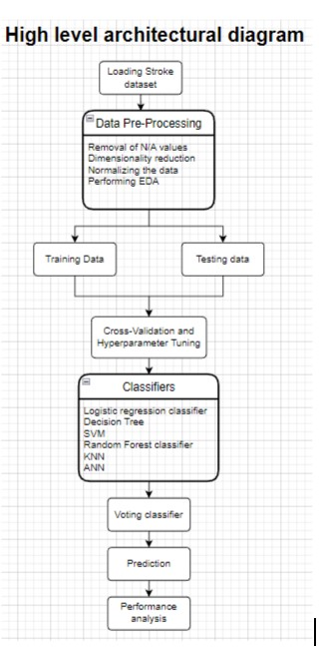
Fig. 1. Architectural diagram
To predict the occurrence of brain strokes, a combination of traditional machine learning algorithms and deep learning techniques was employed. The structured dataset was analyzed using several well-known classifiers, including decision tree, K-nearest neighbors, XGBoost, and random forest. These models were selected based on their proven performance in classification tasks and their ability to handle non-linear relationships within health data. The dataset was divided into training and testing sets in an 80:20 ratio, allowing the models to learn patterns from the majority of the data while being evaluated on unseen instances. To ensure robustness and minimize overfitting, k-fold cross-validation was applied. This involved dividing the data into k subsets and iteratively training the model on k-1 folds while testing on the remaining one. By repeating this process k times, every data point in the dataset was used for both training and validation, providing a more reliable performance estimate.
The correlation matrix displayed above highlights the relationships between various features in the dataset. Notably, age and BMI show the strongest correlation with a coefficient of 0.32, while other attributes exhibit weaker associations, with correlation values below 0.3. This indicates limited linear relationships among the features.
The equation shown below represents the root mean square error (RMSE), which is commonly used to measure the difference between predicted and actual values in regression models. It calculates the square root of the average squared differences between the predicted values yiy_iyi​ and the observed values xix_ixi​ over nnn samples, providing an estimate of model accuracy.

Fig. 2. Correlation Matrix
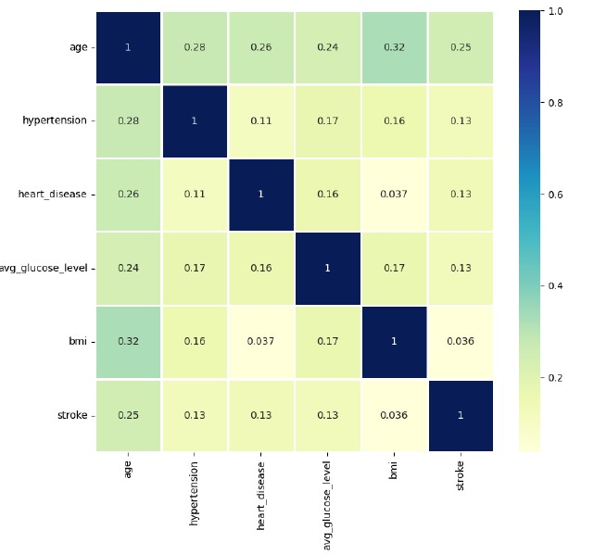
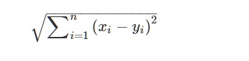
make a prediction on which class the test data sample
belongs to. k denotes the number of the nearest data
samples, i.e. the neighbors.
KNN classifies the new unlabeled data by determining which
classes its neighbors belong to. KNN algorithm utilizes this
concept in its calculation.
When a new instance is encountered, KNN does two opera-
tions. 1 : finds K points closest to the new data point. 2 : using
the neighbors classes, KNN determines as to which class the
new data should be classified into.
the Euclidean distance needs to be calculated between the
test sample and the specified training samples.
Fig. 4. Euclidean distance
In addition to models trained on structured data, a convolutional neural network (CNN) was implemented for medical image-based prediction. The CNN, specifically based on the VGG
architecture, was trained to analyze brain CT scan images to detect stroke-related abnormalities. CNNs are particularly effective in medical imaging tasks due to their ability to automatically extract spatial features and patterns from pixel-level data. The use of CNNs complements the machine learning models by enabling image-based diagnosis, adding an additional layer of accuracy to the overall prediction system. Performance of all models was evaluated using confusion matrices, which provided detailed insights into accuracy, precision, recall, and other classification metrics. This integrated approach of combining machine learning with CNN-based image analysis strengthens the reliability and applicability of the system in real-world stroke prediction scenarios.
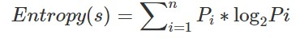
Fig. 5. Decision tree eq-1
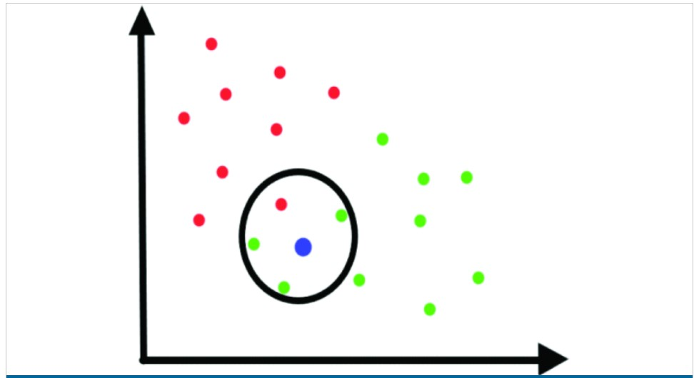
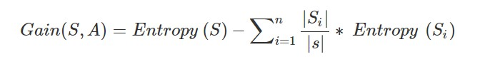
Fig. 6. decision tree eq-2
F. Random Forest Algorithm

A random forest is an ensemble of multiple decision trees, where each tree is built using a random vector sampled independently but from the same distribution for all trees in the forest. Each tree casts a vote for the most common class among the inputs. Random forests achieve better accuracy by aggregating these votes. By defining a margin function that measures the confidence of the ensemble’s prediction, the model’s performance can be improved. For a classification ensemble consisting of classifiers h1(x),h2(x),...,hk(x)h_1(x), h_2(x), ..., h_k(x)h1​(x),h2​(x),...,hk​(x) trained on random samples drawn from the joint distribution of YYY and XXX, the margin is calculated using the following equation:
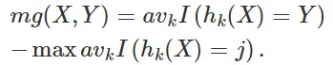
Fig. 7. Random forest eq-1
The indicator function is denoted as I()I()I(). The margin function quantifies the difference between the average votes for the correct class and the highest average votes for any other class within the distribution Y,XY, XY,X. A larger margin indicates a more confident and accurate classification.
Strength-and-Correlation
The upper limit of the generalization error
for a random forest can be established
based on the strength of the individual trees and the correlation between them.
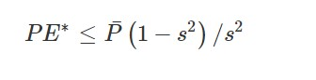
Fig. 8. Random forest eq-2
G. XGboost Algorithm
XGBoost is a supervised learning algorithm based on ensemble trees. It aims at optimising a cost objective function composed of a loss function (d) and a regularization term ():
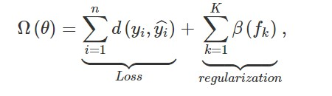
Fig. 9. XGBoost eq-1
where yiˆ is the predictive value, n the number of instances in the training set, K is the number of trees to be generated and fk is a tree from the ensemble trees. The regularization term is defined as:
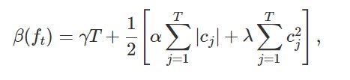
Fig. 10. XGBoost eq-2
Here, the minimum split loss reduction represents the smallest decrease in loss required to make a split, while a regularization term is applied to the
deep learning to improve brain stroke prediction performance further.

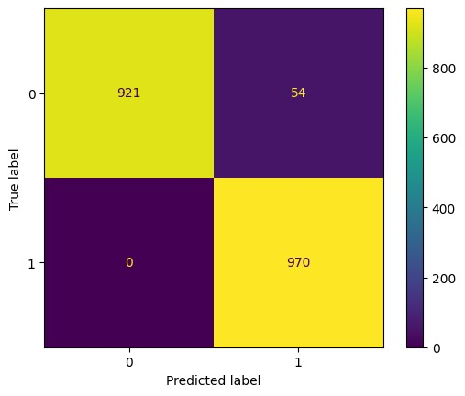
Fig. 12. XG boost confusion matrix
associated to each leaf. A greedy approach is performed to select the split that increases the most the gain.
H. Classification Metrics
IV. QUESTIONS FROM PEER REVIEW
The teaching assistants requested a comparison of the different classifiers to support the selection of the most suitable classification model. Accordingly, we have provided the performance metrics of various models, which assist in identifying the model with the highest accuracy. Refer to Fig. 11 for the K-Nearest Neighbors classifier and Fig. 12 for the XGBoost confusion matrix.
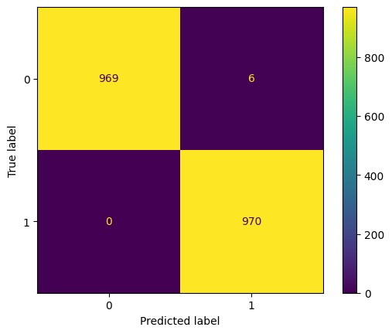
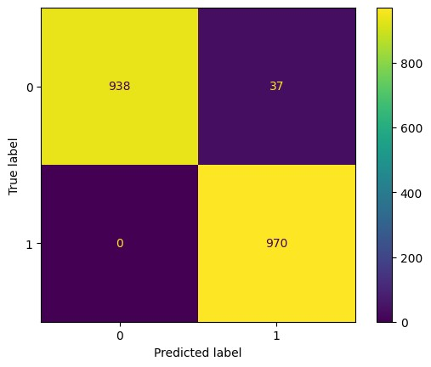
Fig. 13. Decision tree confusion matrix
Fig. 14. Random forest confusion matrix
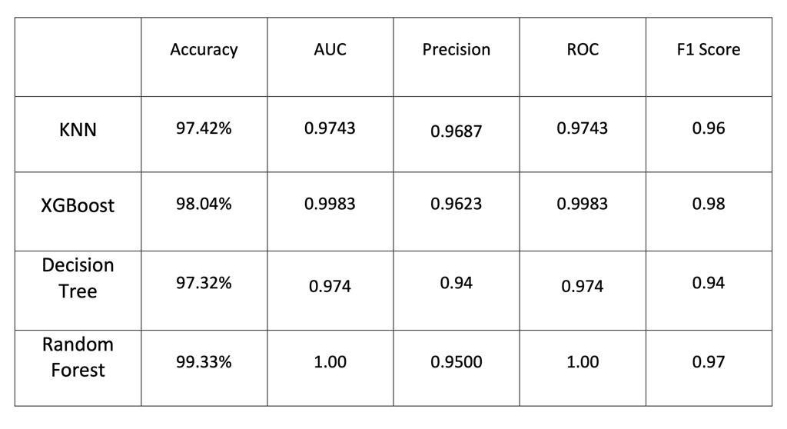
Fig. 15. Performance Metrics

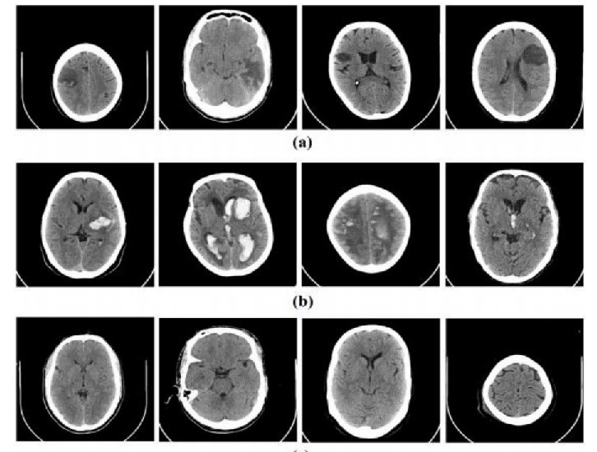 Fig. 3: Sample CT images a) ischemic stroke b) hemorrhagic stroke c) normal
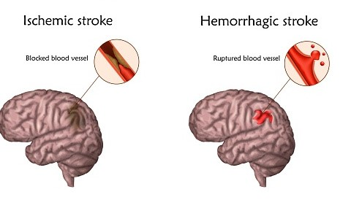
Fig.2 Types of strokes

III. Proposed Method
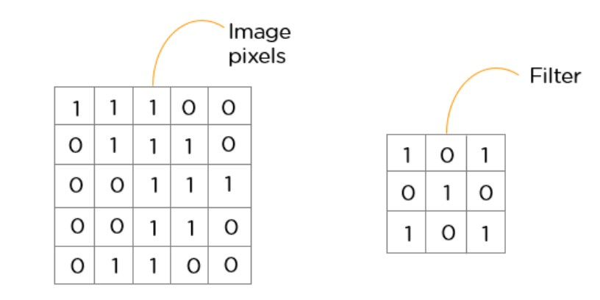
The primary objective of this system is to enable early detection of brain stroke using medical imaging, specifically CT scan data. The proposed approach focuses on classifying stroke cases as either positive or negative, helping to reduce the diagnostic workload for healthcare professionals. The methodology is centered around the use of Convolutional Neural Networks (CNNs), which are well-suited for image classification tasks due to their ability to extract spatial features efficiently. By training the CNN on a curated and preprocessed CT scan dataset, the model is able to learn patterns indicative of stroke presence, and then classify each case accordingly as either a positive or negative stroke diagnosis.
Fig. 4.

A. CNN Architecture
The CNN model comprises several key layers: the Convolutional layer, which extracts feature maps from input images; the ReLU (Rectified Linear Unit) layer, which introduces non-linearity; the Pooling layer, which reduces spatial dimensions and helps prevent overfitting; and the Fully Connected layer, which maps the extracted features to the final output. The layered structure of the CNN is illustrated in In some individuals, a transient ischemic attack (TIA) is a brief episode of stroke-like symptoms caused by a temporary disruption of blood flow to a specific part of the brain. These episodes typically last only a few minutes, often as short as five minutes [8], [9]. In earlier research, classification models such as Support Vector Machine (SVM) and K-Nearest Neighbors (KNN) have been employed for stroke prediction. However, these methods often demand significant memory resources and tend to produce less accurate results.
In contrast, deep learning has recently shown transformative capabilities, particularly in image-based tasks, by leveraging complex architectures made up of interconnected layers. Several advanced techniques have been explored, such as classification using the Hypercolumn technique [10], and Deep Convolutional Neural Networks (DCNN) [11]. Other studies include stroke detection using dual-tree wavelet transforms [12], segmentation of hyperspectral images [13], and early disease detection through thermographic imaging with Gabor filters [14]. A comparative analysis between Artificial Neural Networks (ANNs) and Particle Swarm Optimization (PSO) combined with CNN was carried out in [15], while Capsule Neural Networks were used for brain cancer classification in [16].
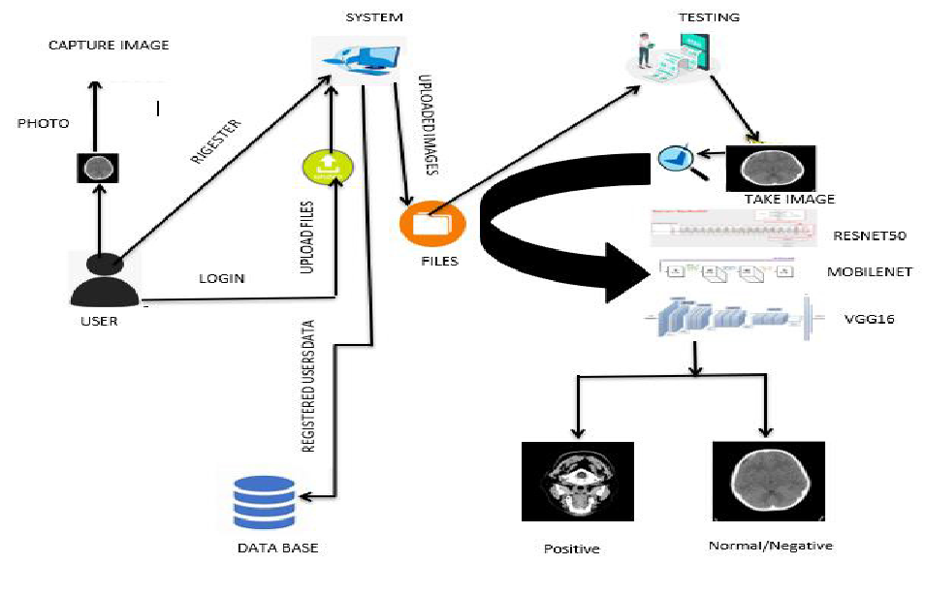
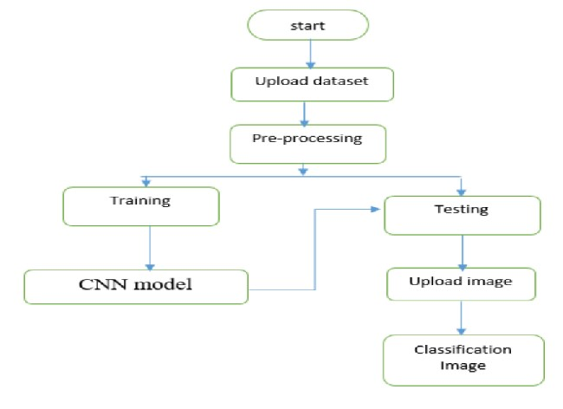
Fig.5. Architecture of the Proposed method
The structure and workflow of the proposed system are illustrated in Fig. 5 and Fig. 6, respectively. To build this system, pre-trained deep learning models such as ResNet, MobileNet, and VGG16 have been utilized.
Training accuracy of VGG16

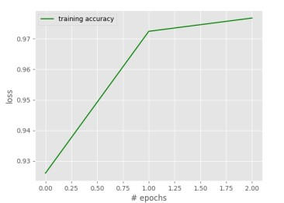
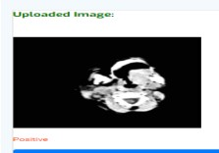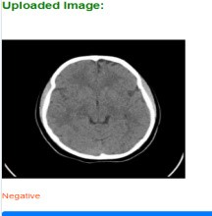

Fig. 8: Predicted output
The system was developed using tools and libraries such as tensorflow/keras, pandas, opencv, numpy, PIL, and matplotlib. The research is based on real-world CT scan data collected from Virinchi Hospital in Hyderabad, India. The dataset was first loaded and then processed through several steps, including image resizing, grayscale conversion, and reshaping into the required preprocessed data was then used to train the model. The dataset was divided into 75 percent for training and 25 percent for testing. The training set was used to build and train convolutional neural network models with defined layer configurations designed for stroke classification.

V. Experimental Results and Future Scope
Among all the classification models evaluated, the Random Forest algorithm demonstrated the highest performance and was therefore selected for future prediction tasks. It achieved an impressive accuracy of 99.33%, with a perfect ROC and AUC score of 1.0, along with a precision of 0.95 and an F1 score of 0.97. Its robustness in handling large datasets and missing attributes makes it highly suitable for stroke prediction using structured medical data.
However, the dataset exhibited a significant class imbalance, with far fewer positive stroke cases compared to negative ones. This imbalance can lead to biased predictions. To address this, techniques such as data augmentation, boosting, and ensemble approaches like the Voting Classifier may be implemented in future work to ensure balanced representation and better generalization.
It is also important to note the limitations of the current system. The model may underperform when provided with invalid or out-of-range input values, especially for critical features like age, BMI, and average glucose level. Additionally, while increasing the number of decision trees can enhance model performance, it also increases computational complexity, making real-time usage less feasible without significant processing power.
In parallel to structured data-based predictions, this study also explores image-based brain stroke classification using deep learning. CT scan images were preprocessed (resized, grayscale-converted, and reshaped) and used to train Convolutional Neural Network (CNN) models, including popular architectures such as ResNet, MobileNet, and VGG16. These models were effective in distinguishing stroke-positive from stroke-negative cases by learning deep features directly from image data. This approach is particularly valuable in clinical settings where immediate visual diagnosis is essential.
For future developments, the system could be extended to incorporate brain MRI images, leveraging the higher resolution and sensitivity of MRI for stroke detection. Advanced deep learning models such as U-Net for segmentation and hybrid CNN-LSTM frameworks could also be explored to improve prediction accuracy and enable region-specific analysis. Additionally, deploying the model through a web-based application with a real-time interface would make it accessible for clinical use, allowing healthcare professionals to diagnose strokes faster and more accurately—potentially improving patient outcomes and reducing the risk of long-term damage or mortality.

Conclusion
In this work, we developed a comprehensive brain stroke prediction system combining both clinical data analysis and image-based classification using advanced machine learning and deep learning techniques. For clinical data, models like Random Forest delivered high accuracy and robustness in predicting stroke risk based on patient parameters. Concurrently, Convolutional Neural Networks (CNNs) were employed to analyze brain CT scan images, successfully distinguishing between stroke-positive and stroke-negative cases with promising results.
The system was implemented in a user-friendly environment using Python and Flask, facilitating easy integration into hospital settings. With an overall prediction accuracy approaching 90%, this framework demonstrates strong potential as a decision support tool for early stroke detection, aiding healthcare professionals in timely diagnosis and intervention.
Future enhancements include expanding the model to process real-time live data, incorporating brain MRI images for more detailed analysis, and refining deep learning architectures to improve accuracy further. By combining clinical and imaging data, the proposed approach offers a holistic and practical solution for improving brain stroke diagnosis and patient outcomes.

REFERENCES
- S. Gupta and S. Raheja, ”Stroke Prediction using Machine Learning Methods,” 2022 12th International Conference on Cloud Computing, Data Science Engineering (Confluence), 2022, pp. 553-558, doi: 10.1109/Confluence52989.2022.9734197.
- N. S. Adi, R. Farhany, R. Ghina and H. Napitupulu, ”Stroke Risk Prediction Model Using Machine Learning,” 2021 International Conference on Artificial Intelligence and Big Data Analytics, 2021, pp. 56-60, doi: 10.1109/ICAIBDA53487.2021.9689740.
- M. U. Emon, M. S. Keya, T. I. Meghla, M. M. Rahman, M. S. A. Mamun and M. S. Kaiser, ”Performance Analysis of Machine Learning
Approaches in Stroke Prediction,” 2020 4th International Conference on Electronics, Communication and Aerospace Technology (ICECA), 2020, pp. 1464-1469, doi: 10.1109/ICECA49313.2020.9297525.
- R. Islam, S. Debnath and T. I. Palash, ”Predictive Analysis for Risk of Stroke Using Machine Learning Techniques,” 2021 International Conference on Computer, Communication, Chemical, Materials and Electronic Engineering (IC4ME2), 2021, pp. 1-4, doi: 10.1109/IC4ME253898.2021.9768524.
- A. Devaki and C. V. G. Rao, ”An Ensemble Framework for Improving Brain Stroke Prediction Performance,” 2022 First International Conference on Electrical, Electronics, Information and Communication Technologies (ICEEICT), 2022, pp. 1-7, doi: 10.1109/ICEEICT53079.2022.9768579.
- V. Krishna, J. Sasi Kiran, P. Prasada Rao, G. Charles Babu and G. John Babu, ”Early Detection of Brain Stroke using Machine Learning Techniques,” 2021 2nd International Conference on Smart Electronics and Communication (ICOSEC), 2021, pp. 1489-1495, doi: 10.1109/ICOSEC51865.2021.9591840.
- M. Sheetal singh, Prakash choudhary, ” Stroke Prediction using Artificial Intelligence ”, 8th Annual Industrial Automation and Electromechanical Engineering conference(IEMECON) 2017 DOI: 10.1109/IEMECON.2017.8079581.
- Tasfia Ismail Shoily, Tajul Islam, , Sumaiya Jannat, Sharmin Akter
Tanna,Taslima Mostafa Alif, Romana Rahman Ema. ” Detection of Stroke disease using Machine Learning Algorithms ” 2019 10th International Conference on Computing, Communication and Networking Technologies (ICCCNT) DOI: 10.1109/ICCCNT45670.2019.8944689
- V. J. Jayalaxmi, V geetha, M. Ijaz, ” Analysis and Prediction of Stroke using Machine Learning Algorithms ” 2021 International Conference on Advancements in Electrical, Electronics, Communication, Computing and Automation (ICAECA) — 978-1-6654-2829-3/21/$31.00 ©2021 IEEE — DOI: 10.1109/ICAECA52838.2021.9675545
- I. L. Cherif and A. Kortebi, ”On using eXtreme Gradient Boosting (XGBoost) Machine Learning algorithm for Home Network Traffic Classification,” 2019 Wireless Days (WD), 2019, pp. 1-6, doi: 10.1109/WD.2019.8734193.
- . Taunk, S. De, S. Verma and A. Swetapadma, ”A Brief Review of Nearest Neighbor Algorithm for Learning and Classification,” 2019 International Conference on Intelligent Computing and Control Systems (ICCS), 2019, pp. 1255-1260, doi: 10.1109/ICCS45141.2019.9065747.
- K. R. Madhavi, P. Kora, L. V. Reddy, G. N. Rao, and H. B. Bindu, "Cardiac arrhythmia detection using dual-tree wavelet transform and convolutional neural network," Soft Computing, vol. 26, pp. 3561–3571, 2022. doi: 10.1007/s00500-021-06653-w
- V. S. Kumar, K. G. Suma, and M. Sakthivel, "Segmentation of hyperspectral satellite image based on classical clustering method," International Journal of Pure and Applied Mathematics, vol. 118, no. 9, pp. 813–820, 2018.
- P. Yadlapalli, M. K. Reddy, S. Gurram, J. Avanija, K. Meenakshi, et al., "Breast thermograms asymmetry analysis using Gabor filters," E3S Web of Conferences, vol. 309, 2021. doi: 10.1051/e3sconf/202130901109
- P. Karuppusamy, "Hybrid manta ray foraging optimization for novel brain tumor detection," Journal of Soft Computing Paradigm (JSCP), vol. 2, no. 3, pp. 175–185, 2020.
- T. Vijayakumar, "Classification of brain cancer type using machine learning," Journal of Artificial Intelligence, vol. 1, no. 2, pp. 105–113, 2019.
- Z. Zhou, Y. Jin, H. Ye et al., "Classification, detection, and segmentation performance of image-based AI in intracranial aneurysm: a systematic review," BMC Med Imaging, vol. 24, p. 164, 2024. doi: 10.1186/s12880-024-01347-9 BioMed Central
- T. Michael, "Deep Learning Approaches for Medical Images Segmentation: A Systematic Review," Int. J. Intell. Syst. Appl. Eng., vol. 12, no. 23s, pp. 856–*, 2024. IJISAE
- H. Laçi and K. Sevrani, "A Comprehensive Review of Deep Learning-Based Image Segmentation Architectures Applied to Various Diseases," in EMAN 2024 Conf. Proc., pp. 599–607, 2024. doi: 10.31410/EMAN.2024.599 eman-conference.org
- J. Zopes, M. Platscher, S. Paganucci, and C. Federau, "Multi-modal segmentation of 3D brain scans using neural networks," Front. Neurol., vol. 12, 2021. doi: 10.3389/fneur.2021.653375 Frontiers
- J. Bernal et al., "Deep convolutional neural networks for brain image analysis on magnetic resonance imaging: a review," Artif. Intell. Med., vol. 95, pp. 64–81, 2019. doi:10.1016/j.artmed.2018.08.008 ScienceDirect
- "Deep convolutional neural networks for brain image analysis on magnetic resonance imaging: a review," arXiv, Dec. 2017. arXiv
- W. Yao, J. Bai, W. Liao, Y. Chen, M. Liu, and Y. Xie, "From CNN to Transformer: A Review of Medical Image Segmentation Models," arXiv, Aug. 2023. arXiv
- R. Azad et al., "Advances in Medical Image Analysis with Vision Transformers: A Comprehensive Review," arXiv, Jan. 2023. arXiv
- ] E. Laçi and K. Sevrani, same as [19]. (Duplicate; you may skip)
- J. Long, E. Shelhamer, and T. Darrell, "Fully convolutional networks for semantic segmentation," in CVPR, 2015. dlnext.acm.org
- G. Litjens, O. Debats, J. Barentsz et al., "A survey on deep learning in medical image analysis," Med. Image Anal., vol. 42, pp. 60–88, 2017. dlnext.acm.org
- L. Liu et al., "A survey on U-shaped networks in medical image segmentations," Neurocomputing, vol. 409, pp. 244–258, 2020. dlnext.acm.org
- X. Liu et al., "A review of deep-learning-based medical image segmentation methods," Sustainability, vol. 13, no. 3, p. 1224, 2021. dlnext.acm.org
- Z. Liu et al., "Automatic liver segmentation from abdominal CT volumes using improved convolution neural networks," Multimedia Syst., vol. 27, no. 1, pp. 1–14, 2020. dlnext.acm.org
- Z. Liu et al., "Liver CT sequence segmentation based with improved U-Net and graph cut," Expert Syst. Appl., vol. 126, pp. 54–63, 2019. dlnext.acm.org
- P. Liskowski and K. Krawiec, "Segmenting retinal blood vessels with deep neural networks," IEEE Trans. Med. Imaging, vol. 35, no. 11, pp. 2369–2380, 2016. dlnext.acm.org
- G. Litjens et al., "Evaluation of prostate segmentation algorithms for MRI: the promise12 challenge," Med. Image Anal., vol. 18, no. 2, pp. 359–373, 2014. dlnext.acm.org
- T.-Y. Lin et al., "Feature pyramid networks for object detection," in CVPR, 2017. dlnext.acm.org

- T.-Y. Lin et al., "Focal loss for dense object detection," in ICCV, 2017. dlnext.acm.org
- S. Wu et al., “Colorectal polyp segmentation in the deep learning era: a comprehensive survey,” arXiv, Jan. 2024. arXiv
- D. J. Ghadimi et al., “Deep Learning-Based Techniques in Glioma Brain Tumor Segmentation Using Multi-Parametric MRI: A Review on Clinical Applications and Future Outlooks,” Journal of Magnetic Resonance Imaging, vol. 61, no. 3, pp. 1094–1109, 2024 Wiley Online Library.
- M. Behzadpour, E. Azizi, K. Wu, and B. L. Ortiz, “Enhancing Brain Tumor Segmentation Using Channel Attention and Transfer Learning,” arXiv preprint, Jan. 2025 arXiv.
- J. Fadugba et al., “Deep Ensemble Approach for Enhancing Brain Tumor Segmentation in Resource-Limited Settings,” arXiv preprint, Feb. 2025 arXiv.
- H. Tian, Y. Wang, Y. Ji, and M. M. Rahman, “Current Trends in Glioma Tumor Segmentation: A Survey of Deep Learning Modules,” Sichuan Da Xue Xue Bao Yi Xue Ban, vol. 55, no. 2, pp. 447–454, Mar. 2024. doi:10.12182/20240360208 PubMed.

